Odd Semester (2021)



**BINUS UNIVERSITY**

**BINUS INTERNATIONAL**

**Assignment Cover Letter**

**(Individual Work)**

|  |  |  |  |  |  |  |  |  |
| --- | --- | --- | --- | --- | --- | --- | --- | --- |
|  | | | | |  | |  | |
| **Student Information**: **First** **Name** | | | | | **Last Name**  **Aranta** | | **Student ID Number**  **2201816202** | |
| 1. | | **Figo** |  | |
|  |  |
| **Course Code** | **: COMP6502** |  |  | | **Course Name** | | **: Introduction to Programming** | |
| **Class** | **: L1BC** |  |  | | **Name of Lecturer(s)** | | : 1. Monica Hidajat | |
|  |  |  |  | |  | |  | |
| **Major** | **: CS** |  |  | |  | |  | |
| **Title of Assignment**  (if any) | Snake Game | |  |  | |  | |  | |
| **Type of Assignment**    **Submission Pattern** | **: Final Project** |  |  | |  | |  | |
| **Due Date** | **: 20-11-2017** |  |  | | **Submission Date** | | **: 20-11-2017** | |

The assignment should meet the below requirements.

1. Assignment (hard copy) is required to be submitted on clean paper, and (soft copy) as per lecturer’s instructions.
2. Soft copy assignment also requires the signed (hardcopy) submission of this form, which automatically validates the softcopy submission.
3. The above information is complete and legible.
4. Compiled pages are firmly stapled.
5. Assignment has been copied (soft copy and hard copy) for each student ahead of the submission.

# Plagiarism/Cheating

BiNus International seriously regards all forms of plagiarism, cheating and collusion as academic offenses which may result in severe penalties, including loss/drop of marks, course/class discontinuity and other possible penalties executed by the university. Please refer to the related course syllabus for further information.

# Declaration of Originality

By signing this assignment, I understand, accept and consent to BiNus International terms and policy on plagiarism. Herewith I declare that the work contained in this assignment is my own work and has not been submitted for the use of assessment in another course or class, except where this has been notified and accepted in advance.

Signature of Student: (Name of Student)

1. Figo Aranta

**The Snake Game**

1. Description

The Snake Game has been there since the beginning of the game and it has always been fun playing it. The Snake Game was first originated in the 1976 arcade game. Snake is also a very common for video games concept name, where the player maneuvers a line which grows in length, with the line itself being a primary obstacle. After a variant was preloaded in 1998 on Nokia Mobil Phones, there was a big amount of Interest in the snake concept as it found a larger audience. There are now over 300 *Snake*-like games for IOS alone. *https://en.wikipedia.org/wiki/Snake_(video_game_genre)*

Game Intro :

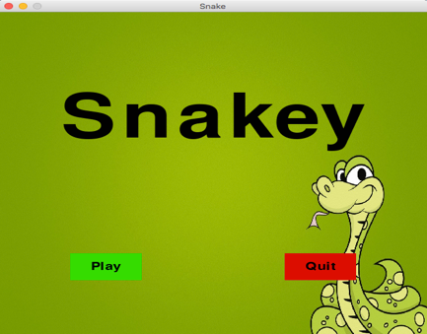

So in the Game Intro, the user can choose 2 options whether to play or to quit.

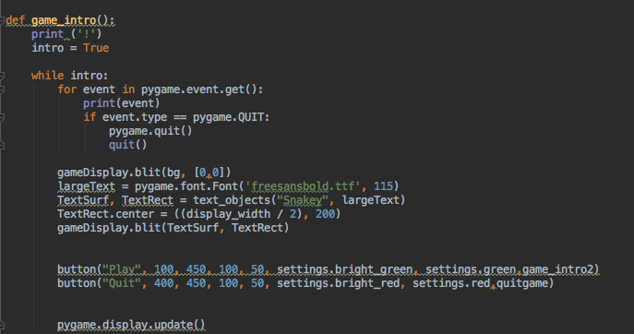

and here is the picture of my code for the game intro.it includes button and the rectangle for the button.

Game Pause:

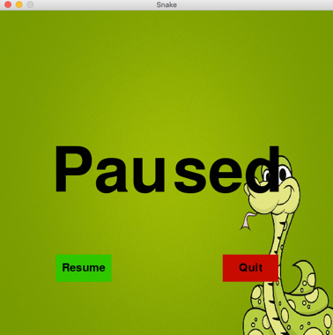

in this function , if we press the button “p” in your keyboard , this pause screen will appear in your screen

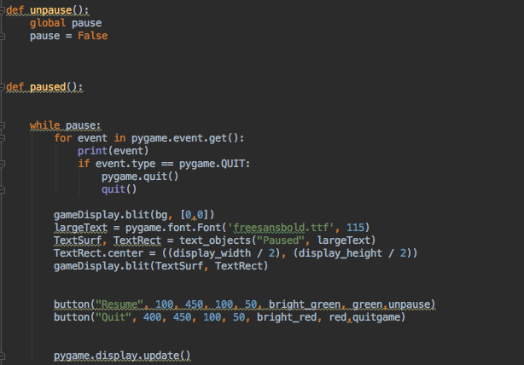

And this is the code for my pause function.

Game Level:

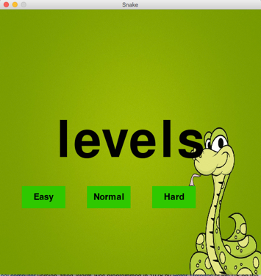

This will appear before the game starts. It requires you to select the levels. The levels also divided into 3 stages. Easy , Normal ,or Hard. Well if you pick easy , the snake is going to move slow but if you pick normal , the snake of course going to move faster than the easy level , and if you pick hard , the snake is going to move super fast , even faster than the normal level.

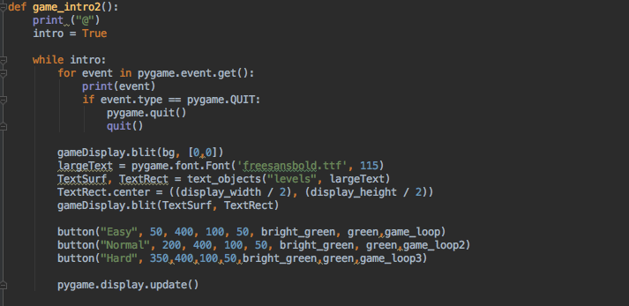

and here is the code for the level function.

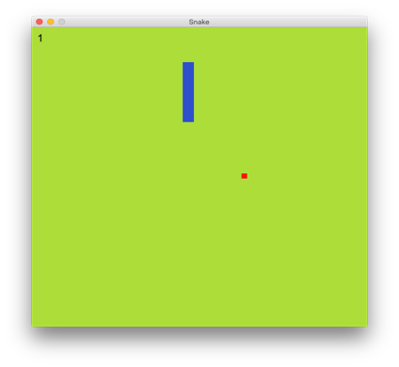Game Loop:

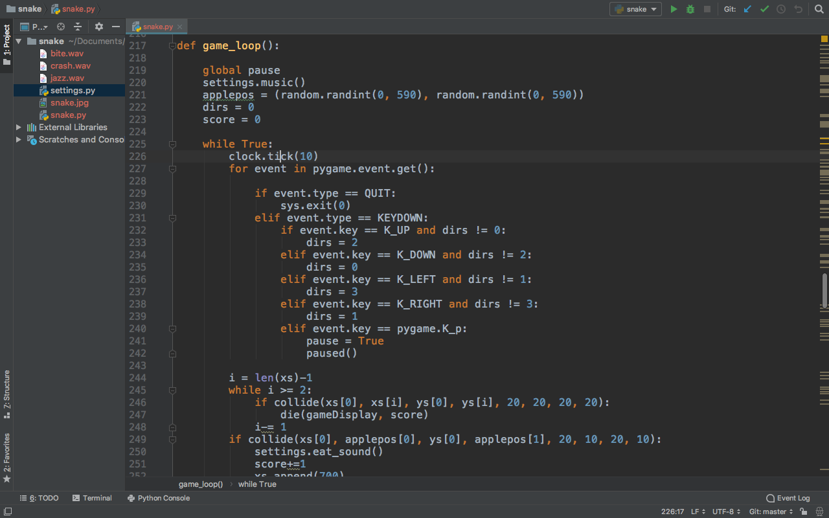So, in this phase. You have already loop into the game and you can start to control your snake to move right,left,up, and down.

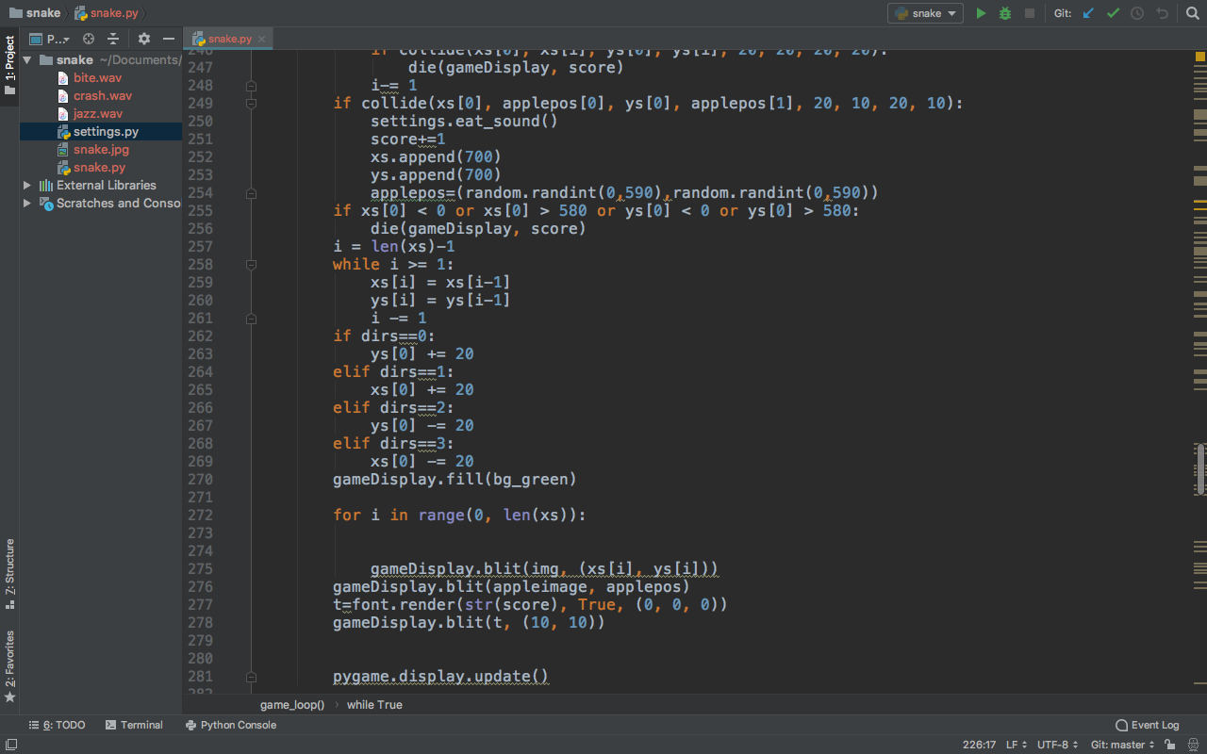

This is the code for the game loop.

Game die 1 :

this will appear in your screen after u collided with the walls or the body of the snake.

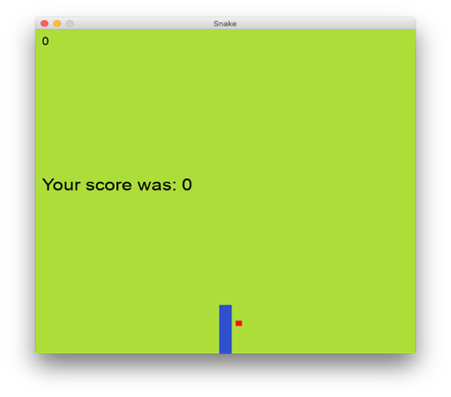

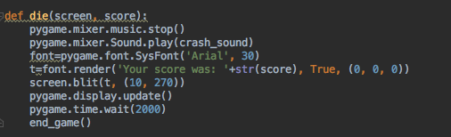

This is the code for the die function. There is also a text printed “your score was” to show your score

Game Die 2:

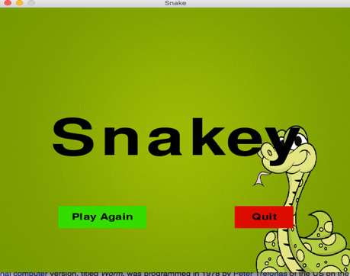

this will appear in your screen after u collided with the walls or the body of the snake.

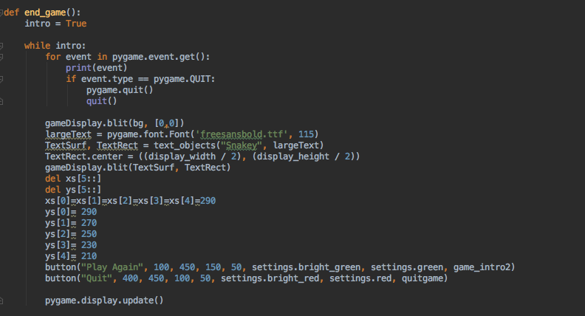

This is the code for game die 2 function. This code is run after the die 1 function is executed.